**Design Project #2 Preliminary Proposal**

**Grumman F14 Tomcat / MiG-21 Bis Fishbed Radar B-Scope over Oscilloscope Vector Graphics**

1. **Hardware Introduction**

This project will simulate the radar B-scope of the F14 or the MiG-21’s radar B-scope along with RWR sound (radar ping, radar lock, launch warning etc.). Both aircraft utilizes vector graphics to display B scope information on a circular CRT, mounted in the RIO’s seat and lower right side of the cockpit respectively. A demonstration of both scopes is shown below:

F14:

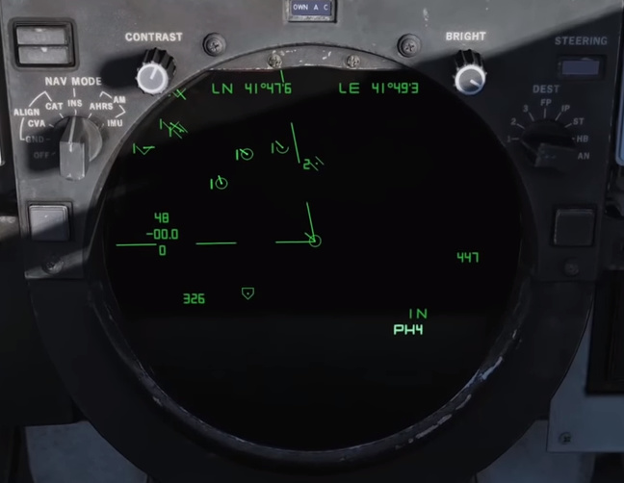

MiG-21:

The goal is to use a combination of an STM328P microcontroller and a TLC7528 dual 8-bit DAC to generate a stereo waveform output, then displaying the generated graphics using X/Y mode on an analog oscilloscope. Depending on available time and/or difficulty, either the F14 (More complex, involves both square/triangle wave and sinusoidal waves) or the MiG-21 (consists primarily of square waves) will be implemented.

As the 8-bit TLC7528 along with the inputs will be taking up most of the available I/O pins on the STM328P, a second STM328P will be used to provide auditory feedback. This co-processor will control the famous Yamaha YM2149 sound chip with a 2-bit input to select between different sound profiles – Bogey Lock, Bogey Launch Warning, missile launch and mute.

2. **Gameplay**

The inputs will be one joystick, one flip switch for MASTER ARM and one button (or more) for missile launch and other features like countermeasures dispense if time permits.

Upon game start, the player will see the bogey pop up on the radar scope. Depending on the aircraft model the player will either have to “hook” the bogey with the joystick or “maneuver” the aircraft till the piper lines up with the bogey and obtain a lock.

Once a lock is obtained, there’s a random chance the bogey will proceed to lock the player. Based on RWR feedback, the player will have to decide between pressing the attack or going defensive.

When the bogey is within missile range (~50 nm for the Cat’s Phoenix and ~7 nm for the R3R), a visual cue will appear on screen. The player will then press the launch button to launch the missile and destroy the bogey.

If the player fails to launch the missile / gets hit by the enemy launch by not notching before the bogey pushes to within 2nm, the game will end with the player being hit by an R73 or AIM-9M.

The end game score will be displayed on the Oscilloscope via existing vector font library.

Inspiration for this project is taken from my experiences in DCS World and recent acquisition of a free Tektronix 5110 mainframe oscilloscope retired from the ME department.

A demonstration of what the scope can do can be found here:

<https://www.youtube.com/watch?v=19jv0HM92kw>